Description program flow for HS1212
In this programme, some subroutines are so complex that I have created separate text for them. SR06

Program start
Indicators 62 and 73 set some description visible. For example, if indicator 62 is on option 17 “credit note”, option 12 “SCAS”, option 20 “follow up order” is visible. If 62 is off, you can use F18 and change the header information.
If G71160 from HSG71PF.PF is empty. Set 62 and 73 off. First the program reads heading information and sets initial values. Then it calls an internal procedure “Readpositions” with dealer ID and claim No. Readpositions use a SQL statement.
This is followed by a Select/When statement to determine the control for the input parameter ART. ART=5 set indicator 60 on, ART=6 indicator 40 is on execute the subroutines SRCHK1 and SR06 and finally a GOTO at the end.

F-Keys
F-Key 3 End:
F-Key 4:
F-Key 5 Refresh:
F-Key 6 New:
F-Key 8 warranty informations:
F-Key 12 cancel:
F-Key 16 new claim:
F-Key 18 change heading informations:

Options
2 change:
4 delete:
5 display:
6 show positions:
7 assign positions:
8 attachments:
9 print claim:
10 send claim:
12 work with claim in SCAS:
15 show claim in SCAS:
17 show credit note:
20 follow up order:

Subroutine SRCHK1:
This routine checks the general claim data and triggers a specific error controlled by indicators. Each 5x indicator triggers an error message.
Check if product is valid. No? Throw error with indicator 50. Check Chassis is valid. No Chassis No.? Only valid with chassis type 4. Not Valid? Throw error 51. Check if repair date is valid. No? Throw error 52. Is mileage valid. No? Throw 53. If chassis no. 0 the mileage must be empty. No? Throw error 54.
Change status if the status is lower than 3. If one error indicator is on change the status to 0. If there is a record in HSG73PF set the status back on 2. If changed status not the old one. Change status in position table HSG71P.

Subroutine SR06:
This subroutines decides if there must be open a new claim for a new position.
Check count of errors. If there are more errors then 9. Ask the user to open a new claim with HS1212WN.
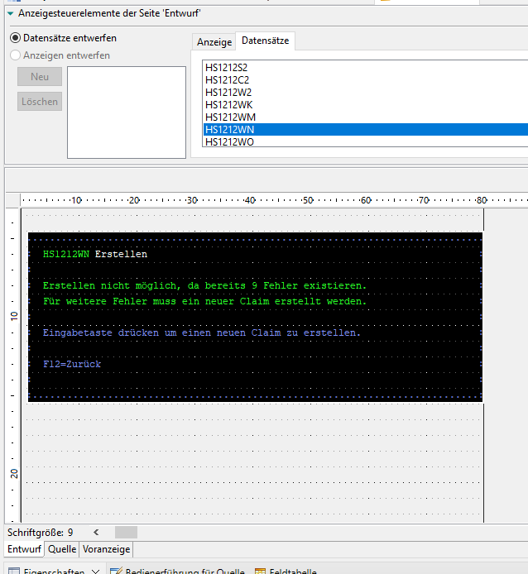

F12 cancel process. If the user press enter display following window HS1212WO, execute subroutine SRNEU.
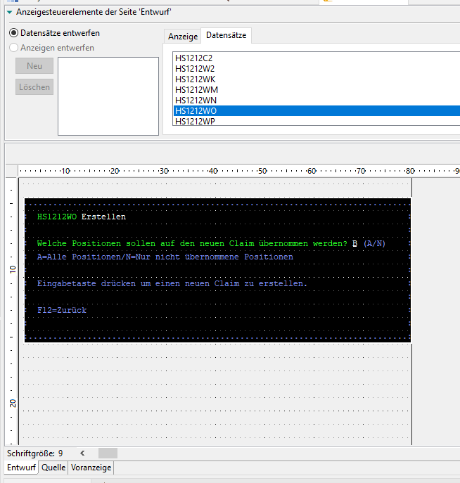
Subroutine SRNEU:
Get next free number. Reade without record lock positions table HSG71P. If there is no free number goto end of routine.

